**Distinction:**

AI vs Method to determine enemies’ power:

Creating simple artificial intelligence was the plan for the prototype phase.

Example: If the player is close enough to the enemy, chase the player (Green circle) and if they are close enough to attack, attack them (Red circle)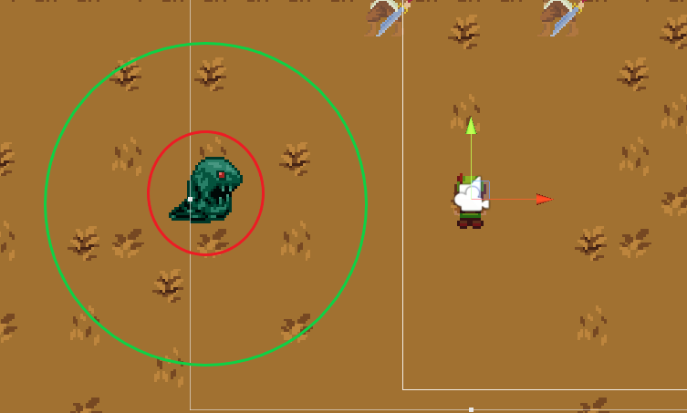

Furthermore, if the player exits the zone marked by the green circle the enemy will stop chasing.

Later (stretch) goals include:

* Restrict the green zone from clipping through walls (unless we start to implement pathfinding, which is a stretch goal)
* If the enemy chases the player out of their spawn zone/ patrol and is no longer able to chase the player, return to their origin. If the player enters the green zone again while the enemy is in the process of returning to their origin, the enemy will chase the player again.
* Readjustment of the green circle (the size of the green circle displayed in the demo image, and the set properties it may or may not have, are to be decided)

**Goal:**

The original goal was to create a method to determine the attributes of the enemies over the progression of the game. These attributes will be simple, with more to be decided and added as stretch goals.

There are a few attributes that all enemies will have (but are not limited to):

Vitality: Defines maximum health

Strength: How much damage is dealt per attack

Stamina: Restricts the amount of consecutive attacks

Dexterity: Establishes Stamina regeneration rate

Movement Speed: Determines how fast an enemy will be able to move (this may be an attribute to the player)

A set of  *n* number of enemies will be generated with random attributes that are all constricted in two different ways. They will all have a predetermined maximum that they cannot exceed.

More enemies will be decided on, worked on, modified, added, and removed as progress on the game progresses.

The images below provide our envisioning of how enemy evolution will occur. Some aspects of the enemy evolution may be added, changed, or removed during development: